PROJECT DOCUMENTATION

TEAM MEMBERS:

*ANSHPREET KAUR RANDHAWA C0737534

*KIRANBIR KAUR C0740055

*ROBANPREET KAUR RANDHAWA C0737536

*VIPAN SOHAL C0737213

**PAGE 1**: The first page will allow the user to either login or register.

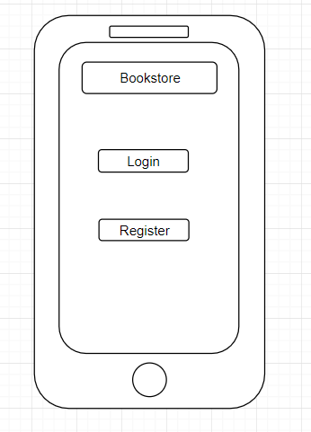

**PAGE 2:** The second Page would be according to the first selection.(either login or register). Register page will have the email verification and the alert message pop up function.

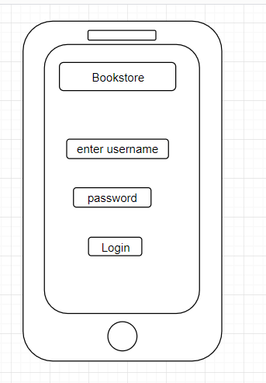

Register-:

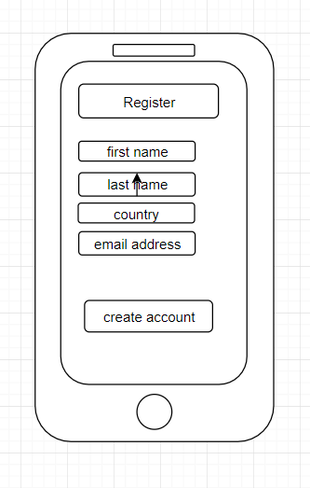

**PAGE 3:** The third page would be the welcome screen of the bookstore site. Welcome screen will display the name of the user logged in with the Hi message. It will have the features such as list of the books available along with the price, author name and year of publishing. User can also search for the particular book in the search tab. The user can also save the book that he want to borrow , he can save that book .If he save a book, no other user can save that book if he is the 6th user. There would be limited books in the stock (5 books of each category).

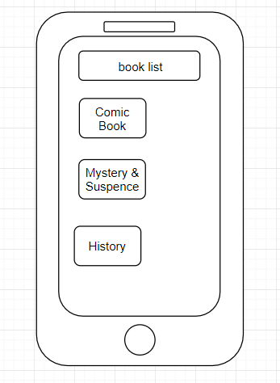

When the user click on the category of books, the next screen shows the description of the selected book along with their price. User can also see the reviews that have given by the users about that book and also can add feedback about that book. When user click on the buy option , the payment screen will open and user can make the payment.

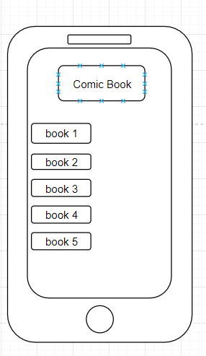

Description-: Review-:

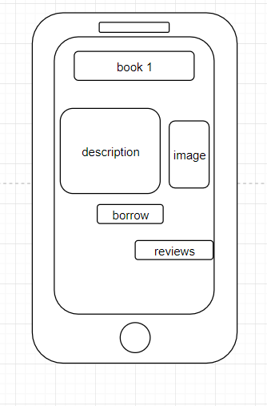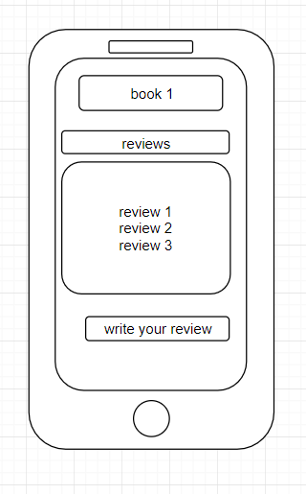

**PAGE 4:**  The page fourth will allow the user to make the payment based on for how many days he wants to borrow the books.

